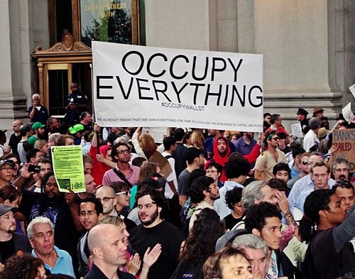 | Occupy Wall Street Lesson Plan  Should students support or oppose the “Occupy” movement?  note: you can save a copy of this and other handouts as Google Doc or download it as a Word doc so you can save and edit it to fit your needs. Go to the “File” dropdown menu, above.

Introduction: The Occupy Wall Street protests that began in New York on September 17 have since spread around the country and abroad, sparking continued debate over the protesters’ grievances, demands, identity, and tactics. This lesson plan presents a balanced approach to teach about the Occupy movement in high school classrooms. The focus of the lesson is for students to evaluate the Occupy movement and decide whether they support or oppose it. Carefully selected C-SPAN video clips are supplemented with articles on high, medium, and low reading levels. Additional resources for further analysis are provided at bottom of the web page.

Objectives: Students will evaluate the Occupy Wall Street movement and defend a position in support or opposition of the movement.

Timing:
- A full analysis of this issue will take about three class periods of about an hour each.
- If you have only one class period, start with the “Background knowledge” section of the note-taking handout, then do the “Take a Stand” activity, and continue with note-taking on the C-SPAN videos supporting and opposing Occupy movement. Each video is less than 10 minutes long. Conclude with a final “Take a Stand” activity so students can change their position from where they stood at the beginning of class based on what they learned in the lesson.

Full Procedure:
1. Give students the note-taking handout or give them access to it online (they can save a copy of the Google Doc to take notes electronically) and have them complete questions #1-3 to see what background knowledge they have about the Occupy movement.

2. Lead students through a “Take a Stand” activity to see whether they support or oppose the movement before learning more about it. Ask students for their answers and tell them that they’re going to learn much more about it, so it’s OK if they don’t have a strong position at this point. They’ll do another “Take a Stand” activity after learning the arguments on both sides.

3. Give students the Vocabulary Preview handout, or give them access to it online (they can save a copy of the Google Doc to take notes electronically). Complete this vocabulary preview as a whole class, in small groups, or individually before watching the videos and reading the articles.

4. Return to the note-taking handout to answer questions #4-6. To do this, students will need access to the Wikipedia article and the first C-SPAN video of protesters in Zuccotti Park. You can do this as a whole class or individually. They only need to read the introductory part of the Wikipedia article. Additional introductory information is found below the first video and includes the New York Times "Times Topics" as well as more demographic information about the protesters from the Christian Science Monitor report and a Wall Street Journal poll.

5. Now it’s time to explore the arguments supporting and opposing the Occupy movement. Give students the last two pages of the note-taking handout (one page is for supporting arguments, the other is for opposing arguments). These two pages can be copied back-to-back, and you may need additional copies if each student reads multiple articles in addition to the videos.

Note: The handout focuses students on the key questions on which supporters and opponents of the movement disagree:
- what is this movement about?
- who are the protesters?
- what are the causes and solutions of our economic problems?
- why should students support or oppose the Occupy movement?

Be aware that these questions open up some deep and complex economic issues that may invite further analysis. For example, supporters and opponents of the movement fundamentally disagree about the causes of the financial crisis and recession. Supporters tend to blame corporate greed and a lack of government regulation, while opponents blame the government for forcing banks to lend to sub-prime borrowers who then defaulted on their loans. These disagreements are alluded to in the high-level articles by Paul Krugman and Peter Wallison. Developing and defending a position on the causes of the financial crisis would require much more time and study than planned for this deliberation.

One C-SPAN video supporting the Occupy movement and one C-SPAN video opposing the Occupy movement has been provided. Watch these as a class and help students identify the conflicting arguments. Students should take notes on the note-taking handout as they watch.

After viewing, taking notes, and discussing the videos together, assign students to read articles on one side or both sides of the issue. Three articles have been provided for each side, at three different reading levels. There are many ways to approach these articles; students may start with the lowest level article and work their way up to the highest level, allowing students to self-differentiate based on their reading speed and comprehension. Or you may pair students up and have them read at the appropriate level, then discuss with a student who read the opposing article at the same level.

· lowest reading level
·· medium reading level
··· highest reading level

Articles supporting the Occupy movement:
· Occupy Wall Street: A Timely Call for Justice, Eugene Robinson, Washington Post
·· America’s Primal Scream, Nicholas Kristof, New York Times
··· Losing Their Immunity, Paul Krugman, New York Times (this article pairs well with Wallison’s)

Articles opposing the Occupy movement:
· Are we the Wall Street Protesters?, Bill O'Reilly, Creators Syndicate
·· You want more equality? Support More Capitalism!, David Harsanyi, The Blaze
··· Wall Street’s Gullible Occupiers, Peter Wallison, Wall Street Journal (this article pairs well with Krugman’s)

If you have time, or if a student finishes reading and note-taking quickly, explore the additional web resources at the bottom of the page. Multiple infographics are provided; some infographics illuminate issues that supporters of the movement emphasize, like the degree of economic inequality that exists in the United States, while others illuminate issues that opponents of the movement emphasize, like the percent of federal income taxes paid by the highest income earners. The additional articles and opinions provide further support and opposition to the movement. Occupy Oakland has recently stolen the headlines from Occupy Wall Street, so a link is provided for more coverage of these developments.

6. After students have read and taken notes on the articles, choose a deliberation strategy to engage in an informed discussion or debate about this issue. You may assign students to a position or let them choose. A public forum debate is a great way to analyze both sides of this issue.

7. Do a final Take a Stand activity to see how students’ positions have changed after learning.

8. Assessment could be measured with a position paper, a written summary of the leading arguments on both sides of the issue, or participation in the other activities.

