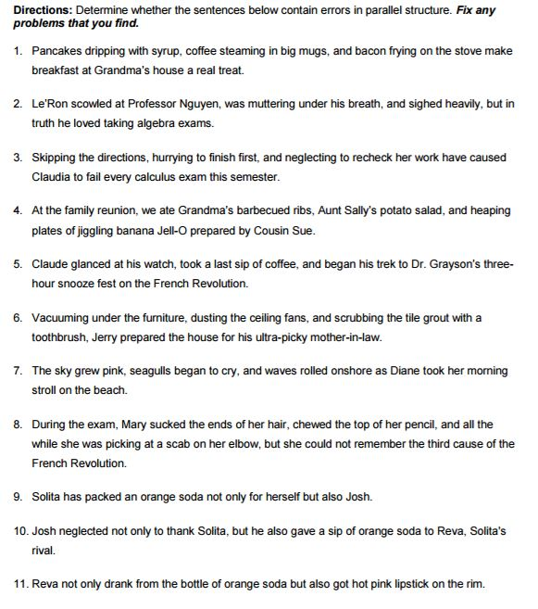

Parallel Structure Homework 2

You may use the back to re-write sentences.

Parallel Structure Homework 2

You may use the back to re-write sentences.