To contact, or not to contact, that is the question:
Exploration of Uncontacted Tribes around the world
Unit 5 PBL project

Task: You will create a presentation for your peers, including a PSA (Public Service Announcement), which informs and persuades others of the importance of either leaving uncontacted tribes alone, or introducing them to modern society. In order to prepare for the PSA the following requirements must be meet.
Task #1 Complete “Analyzing a Secondary Source” Individual Grade _____ / 70
Task # 2 Complete TWO Film Analysis Worksheets Individual Grade ______ / 30
Task # 3 Complete Problem/Solution Graphic Organizer Group Grade ______/ 20
Task # 4 Complete Ethos /Pathos/Logos Graphic Organizer Group Grade ______/ 30
Product: You will create a PSA that tells the story about the uncontacted tribe of your choice. How you do this is up to you. You may use the technology of your choice- We Video, iMovie, moviemaker, etc. Please try to go above and beyond. Each member of the group will also contribute an article summary to an annotated bibliography.
PSA Requirements: Video should be submitted to Youtube or brought in on a DVD (video must play on day of presentation or it will be counted as a zero, so test in advance). You may also email to submitpsa@gmail.com
PSA Rubric
CATEGORY | 4 - Above Standards | 3 - Meets Standards | 2 - Approaching Standards | 1 - Below Standards
Evidence and Examples | Specific and relevant, examples of ethos, pathos and logs are include. | Most of the evidence and examples are specific, relevant, with explanations of ethos pathos and logos. | At least two examples are included of ethos pathos and/or logos. | Evidence and examples of ethos, pathos and logos are NOT relevant AND/OR are not explained.
Support for Position | Includes 3 or more pieces of evidence of position statement and solutions. | Includes 2 to 3 pieces of evidence of position statement and solutions. | Includes 2 pieces of evidence of evidence of position statement and solutions | Includes 1 or fewer pieces of evidence of evidence of position statement and solutions.
Sources | All sources used for quotes, statistics and facts are credible and cited correctly. | All sources used for quotes, statistics and facts are credible and most are cited correctly. | Most sources used for quotes, statistics and facts are credible and cited correctly. | Many sources are suspect (not credible) AND/OR are not cited correctly.
Visual Representation | Video played readily. Video is visually appealing – can be seen and heard. Contains appropriate music/sound. Video is Creative, Shows Effort, and Authentic. | Some issues with video playing. Video is somewhat visually appealing – can be seen and heard. Contains appropriate music/sound. Video is Creative, Shows Effort, and Authentic. | Some issues with video playing. Video is somewhat visually appealing – can be seen and heard. Contains appropriate music/sound. Video is Creative, Shows Effort, and Authentic. | Limited video. Presentation is not visually appealing – cannot be reasonably seen and heard. Contains inappropriate music/sound.

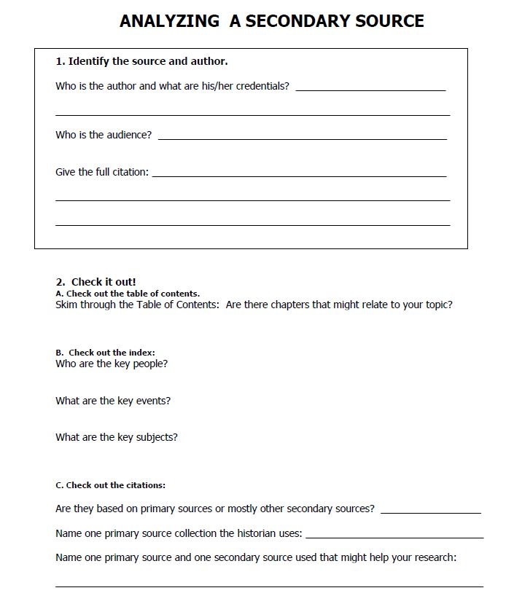

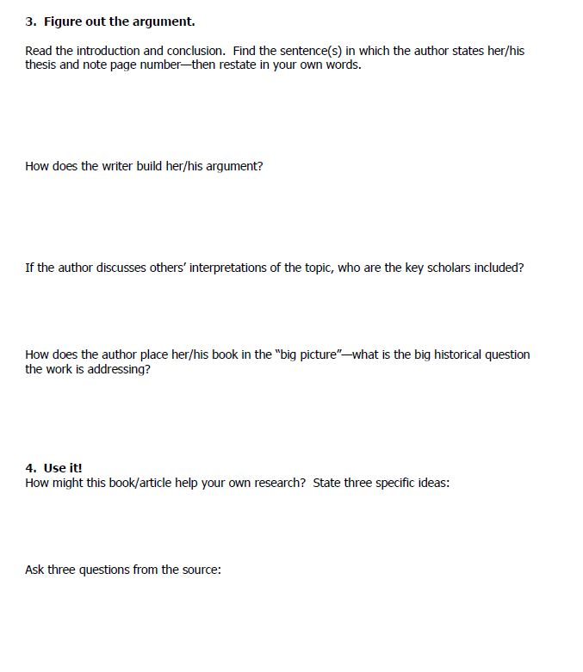

Documentary Film Analysis Worksheet
Step 1. Pre-viewing

Title of Film: Date Released:
Principle filmmaker(s):
What do you think you will see in this motion picture? List three concepts or ideas that you might expect to see based on the title of the film or what you already know about this film.

Step 2. Viewing

Type of documentary (check all that applicable items):
__________ Advocacy for social concerns __________ Biography __________ Career Profile
__________ Community History __________ Research/Factual __________ “How To”
__________ Training/Orientation __________ Investigative __________ News/Special Events
___________Skits & Spoofs __________ Travel/tourism __________ Nature

Physical qualities of the film: Describe all that apply. (Feel free to use a bulleted list if you wish. You don’t need complete sentences, but you should be doing this while you watch the film. Feel free to add anything not listed that you consider important so that you don’t forget it later. )
Narration/voice Over:

Music/Background noise/Special effects:

Interviews (Whom/why?):

Graphs/Maps/Pictures

Mood or tone/emotions evoked:

How camera angles, lighting, music, narration, and/or editing contribute to creating an atmosphere:.

Step 3. Post-viewing
1. What is the principal subject of this documentary? What is its principal purpose? Does it argue for a position? Does it critique a position? What kind of impact does it seek to achieve with - and upon - its intended audience?

2. Does this documentary film make specific choices about what material is to be recorded in relation to the direct observation by the camera operator/director? If so, what kinds of choices, of what should be included and what not, and what kinds of images should be emphasized and what de-emphasized? What, in short, does the documentary film maker look at, and encourage us to look at - and to see - as most important about the principal subject of his or her film?

3. Does this documentary film include directly solicited observation, information, reflection, or commentary by witnesses, experts, and other participants in relation to the documentary subject? What kinds of witnesses, experts, and/or other participants does the film maker find most useful, how does she or he use them to get the film's chief points across, and what kind of response does the film maker seek to evoke by using these subjects as she or he does?

4. Does the documentary film maker use any other kinds of illustrative or suggestive material (such as animated or still photographic images, and dramatic reconstructions or reenactments) to get her or his points across? If so, what, and to what effect?

5. Does the documentary film maker edit live footage, archival footage, direct interviews, retrospective interviews, and other illustrative or suggestive scenes and images to take a stance and argue for a position? Does the documentary film maker arrange the edited film according to a particular kind of logical pattern, and, if so, what is this pattern? What, in other words, is the organizing principle that the film maker follows in deciding what shots to place where and in what sequence? What principal overall aims appear to guide the choices the film maker makes in editing the film as she or he does?

6. How would you evaluate the effectiveness of this documentary film? Why?
7. Write a question to the filmmaker that is left unanswered by the motion picture.

Documentary Film Analysis Worksheet
Step 1. Pre-viewing

Title of Film: Date Released:
Principle filmmaker(s):
What do you think you will see in this motion picture? List three concepts or ideas that you might expect to see based on the title of the film or what you already know about this film.

Step 2. Viewing

Type of documentary (check all that applicable items):
__________ Advocacy for social concerns __________ Biography __________ Career Profile
__________ Community History __________ Research/Factual __________ “How To”
__________ Training/Orientation __________ Investigative __________ News/Special Events
___________Skits & Spoofs __________ Travel/tourism __________ Nature

Physical qualities of the film: Describe all that apply. (Feel free to use a bulleted list if you wish. You don’t need complete sentences, but you should be doing this while you watch the film. Feel free to add anything not listed that you consider important so that you don’t forget it later. )
Narration/voice Over:

Music/Background noise/Special effects:

Interviews (Whom/why?):

Graphs/Maps/Pictures

Mood or tone/emotions evoked:

How camera angles, lighting, music, narration, and/or editing contribute to creating an atmosphere:.

Step 3. Post-viewing
1. What is the principal subject of this documentary? What is its principal purpose? Does it argue for a position? Does it critique a position? What kind of impact does it seek to achieve with - and upon - its intended audience?

2. Does this documentary film make specific choices about what material is to be recorded in relation to the direct observation by the camera operator/director? If so, what kinds of choices, of what should be included and what not, and what kinds of images should be emphasized and what de-emphasized? What, in short, does the documentary film maker look at, and encourage us to look at - and to see - as most important about the principal subject of his or her film?

3. Does this documentary film include directly solicited observation, information, reflection, or commentary by witnesses, experts, and other participants in relation to the documentary subject? What kinds of witnesses, experts, and/or other participants does the film maker find most useful, how does she or he use them to get the film's chief points across, and what kind of response does the film maker seek to evoke by using these subjects as she or he does?

4. Does the documentary film maker use any other kinds of illustrative or suggestive material (such as animated or still photographic images, and dramatic reconstructions or reenactments) to get her or his points across? If so, what, and to what effect?

5. Does the documentary film maker edit live footage, archival footage, direct interviews, retrospective interviews, and other illustrative or suggestive scenes and images to take a stance and argue for a position? Does the documentary film maker arrange the edited film according to a particular kind of logical pattern, and, if so, what is this pattern? What, in other words, is the organizing principle that the film maker follows in deciding what shots to place where and in what sequence? What principal overall aims appear to guide the choices the film maker makes in editing the film as she or he does?
6. How would you evaluate the effectiveness of this documentary film? Why?
7. Write a question to the filmmaker that is left unanswered by the motion picture.

Problem Solutions Graphic Organizer
What do you think are the three most significant issues that uncontacted tribes face when introduced to modern society? | What are two-three possible solutions to these issues?

BEFORE FILMING COMPLETE THE FOLLOWING GRAPHIC ORGANIZER TO DETERMING EXAMPLES IN YOUR PSA
