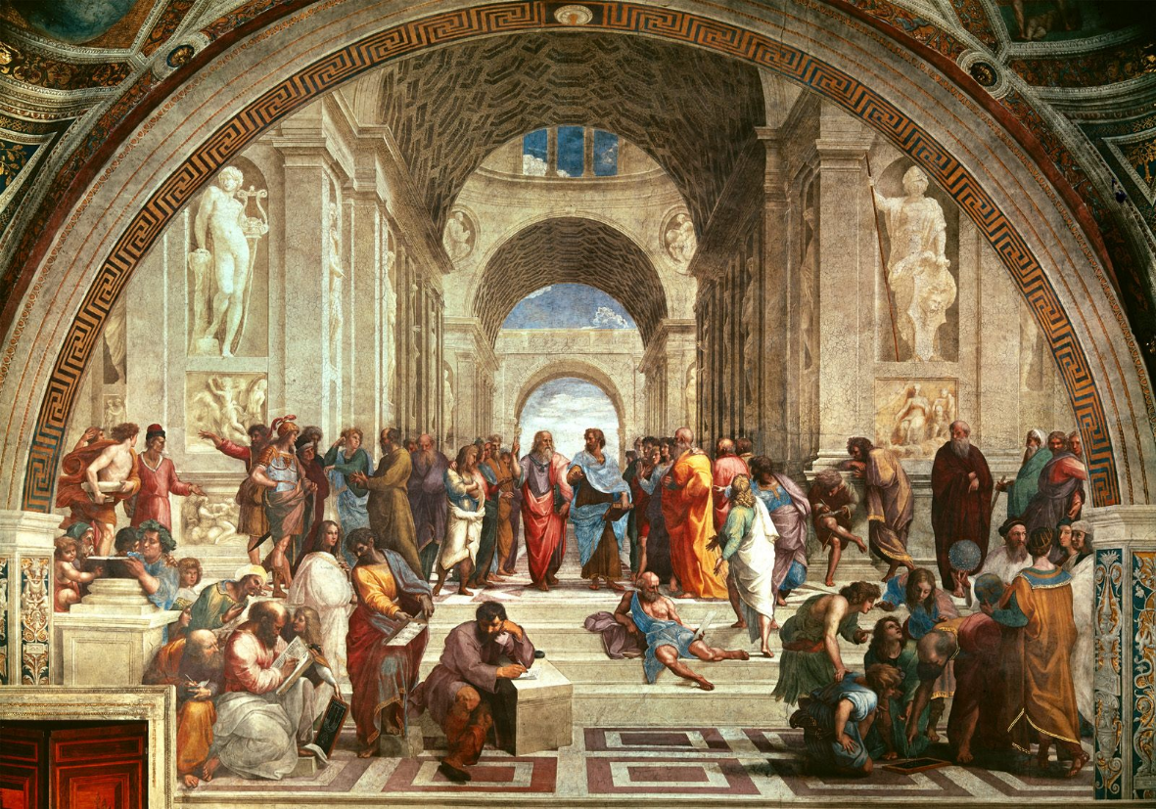

1. Complete an art critique for each picture.
2. Complete each step of the DAIJ art critique process.
   1. Your interpretation should include an explanation of the significance during the Age of Exploration/Renaissance.
   2. Your analysis must include two elements of art connections
3. Each DAIJ “step” should be at least two sentences. The analysis must be at least four sentences.
4. Your critique must be submitted via the blog.
   1. Please use the Art Tab and then select Age of Exploration for your period.
   2. Leave a comment that includes your submission

