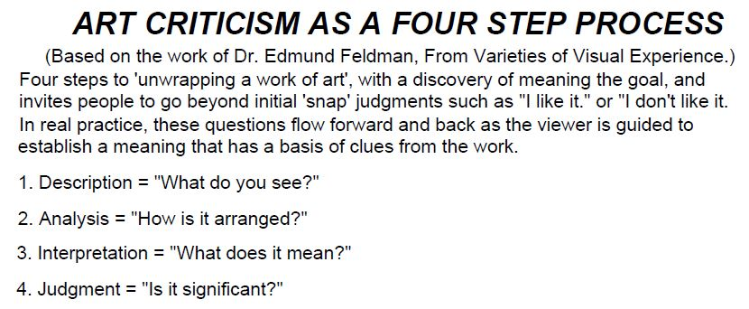

**Antigone Assignment Task**

1. Select a picture
2. Complete each step of the DAIJ step process.
   1. Your interpretation should include an explanation of the significance in Antigone
3. Each DAIJ “step” should be at least two sentences. The judgement must be at least four sentences.
4. Your analysis must be submitted via the blog.
   1. Please use the Art Tab and then select Antigone Art Analysis for your period.

Picture A Picture B Picture C

