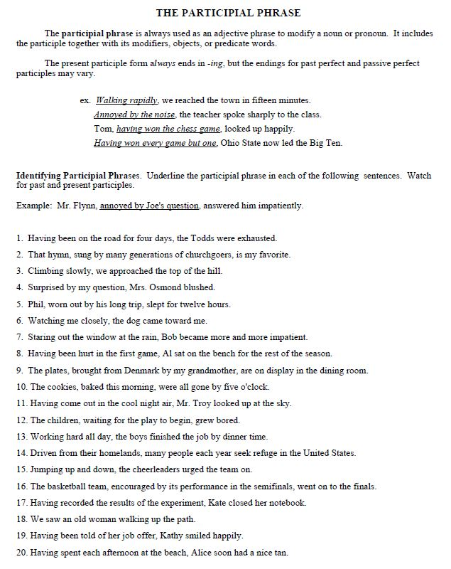

Exercise: Building Sentences with Participial Phrases
- The dishwasher was invented in 1889.
The dishwasher was invented by an Indiana housewife.
The first dishwasher was driven by a steam engine.
Example: Invented by an Indiana housewife in 1889, the first dishwasher was driven by a steam engine.
- I took small sips from a can of Coke.
I was sitting on the ground in a shady corner.
I was sitting with my back against the wall.
- I was sitting on the window ledge.
The ledge overlooked the narrow street.
I watched the children.
The children were frolicking in the first snow of the season.
- The first edition of Infant Care was published by the U.S. Government.
The first edition of Infant Care was published in 1914.
The first edition of Infant Care recommended the use of peat moss for disposable diapers.
- The house sat stately upon a hill.
The house was gray.
The house was weather-worn.
The house was surrounded by barren tobacco fields.

- I washed the windows in a fever of fear.
I whipped the squeegee swiftly up and down the glass.
I feared that some member of the gang might see me.
- Goldsmith smiled.
He bunched his cheeks like twin rolls of toilet paper.
His cheeks were fat.
The toilet paper was smooth.
The toilet paper was pink.
- The roaches scurried in and out of the breadbox.
The roaches sang chanteys.
The roaches sang as they worked.
The roaches paused only to thumb their noses.
They thumbed their noses jeeringly.
They thumbed their noses in my direction.
- The medieval peasant was distracted by war.
The medieval peasant was weakened by malnutrition.
The medieval peasant was exhausted by his struggle to earn a living.
The medieval peasant was an easy prey for the dreadful Black Death.
- He eats slowly.
He eats steadily.
He sucks the sardine oil from his fingers.
The sardine oil is rich.
He sucks the oil with slow and complete relish.

